EDUCATIONAL RESEARCH

AT

SUZUKI CHARTER PUBLIC SCHOOL (SCS)

EXPERIENCES, IMPACT AND IMPLICATIONS

APRIL 2023

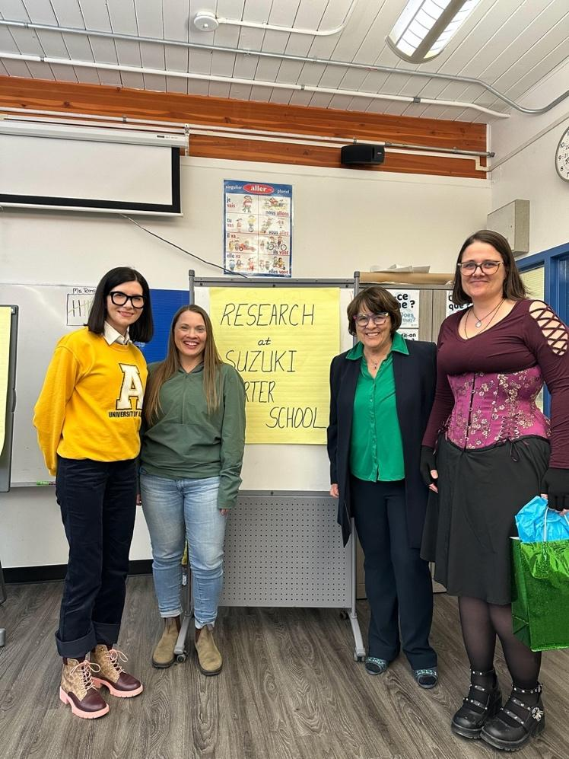

Prepared by: Dr. Lynne Paradis
RESEARCH AT SUZUKI CHARTER SCHOOL

Charter Schools were designed with innovation and research as dimensions of the school experience. Each Charter identifies the unique aspects of school operation that provide opportunities for Alberta children to engage in education with a specific focus (e.g., music at Suzuki, fine arts at Calgary Arts Charter, Indigenous culture at Mother Earth Charter).
When research is conducted in Charter schools there are findings that inform further program developments and could be of interest to the broader education community. Research is encouraged in partnerships developed with post-secondary institutions. One advantage of post- secondary institutions working with Charter Schools is that the access to the schools to carry out authentic research is more convenient than access to other school systems where approval processes are cumbersome. In Charter Schools, it is an expectation that research is carried out and the Board of Directors, educators and family communities understand that research is part of the Charter School experience.

Suzuki Charter School has a long history of active involvement in educational research. Since 1995 when the school charter was approved, many research projects have been initiated. Some have been more successful than others, some have had short terms (a few months) and more recently, longer term studies over a five year span have been notably successful. Many projects have been in partnership with other Charter schools, some have been partnerships with public/separate schools, and various post-secondary institutions have been partners in the process (University of Calgary, University of Alberta). As part of a commitment to research, the Board of Directors and school administration have learned from successes and challenges. This learning is reflected in the current practices that are in place to optimize research as part of school operations

- STRATEGIES THAT HAVE CONTRIBUTED TO RESEARCH SUCCESSES AT SCS
.
- DEVELOPMENT OF A SCHOOL POLICY ON RESEARCH

The Board of Directors and Superintendent review school policy annually and the research policy on educational research identifies that: a) educational research is an ongoing event,
b) partnerships with post-secondary institutions are encouraged, c) educational research forms part of the annual education plan and annual education results report, d) regular updates on research are shared with the Board of Directors at regular school board meetings, e) parents are informed about the role of research in the school and expect it as part of regular operations, and e) the experiences of research are shared with the school community and celebrated.

Having a stated policy on educational research ensures that attention is given to the research dimensions of Charter schools.

- SCHOOL PARTICIPATION IN THE ALBERTA RESEARCH NETWORK

School Administration personnel are active in the Alberta Research Network as participants in provincial meetings and often as presenters sharing research initiatives in the school. Participation in the ARN brings school administration and faculty in regular contact with post- secondary individuals who are active in research in Alberta and also provides school opportunities for further research opportunities through development of personal relationships with research leaders in the province.

- EXPECTATIONS FOR FACULTY AND ADMINISTRATION

As part of annual professional growth plans and routine staff evaluations, the conversation of research is addressed. School administration are responsible to identify goals that support research and the annual evaluation of the Superintendent and Board includes indicators demonstrating attention to research. Teaching and non certificated staff are involved where appropriate with all staff expected to support school research initiatives. Participation takes a variety of forms pending on the nature of the research. Some initiatives are targeted at specific grades, others to focussed areas of educational study, and this impacts which faculty are involved on an annual basis. As part of the school culture, educational research is presented as an important dimension that helps inform effective instruction in the school. Further to new research projects, there is a commitment that faculty consider existing quality research that informs current practice.

- ESTABLISHMENT OF A NETWORK WITH EDUCATIONAL RESEARCHERS

The school supports that research takes time, resources and energy. Given the primary responsibility of the school faculty is to instruct students, research commitments must be carefully approached to ensure that quality classroom instruction is not impacted negatively. For this reason, there is an acceptance that relationships with post- secondary institutions are essential in the research support process. Most teachers are not trained as researchers but they can grow professionally through involvement in research. A great deal can be learned through professional development activities where teachers and educational researchers participate in research discourse. Engaging researchers from post= secondary and having them identified as the lead in research initiatives is essential to ensure that research is quality-driven and that projects undertaken are fully operationalized.

At SCS, a relationship with the Education Faculty at the University of Alberta has been fostered and developed over many years. Effort in sustaining and strengthening these relationships is the responsibility of senior and school administration. This includes annual meetings with University of Alberta individuals who are active in research, exploration of opportunities for research involvement and periodic discussions with Deans and other university administrators on research partnership opportunities. Educational research is a line item in the budget and these funds are used to support costs incurred in research and in scheduled activities to meet with university contacts.

- STAFF SHARING OF RESEARCH EXPERIENCES

All faculty are encouraged to be actively involved in professional development activities that relate to their personal, professional growth plans and school priority areas. Following personal learning experiences, staff are given the opportunity to share new learning with their peers as part of regular school professional development ideas.

Research Snapshots is a new approach to staff involvement in research sharing. This initiative is open to all faculty (music instructors and support staff who have messages to share). A template is provided by school administration to guide the development of a written review that is shared with staff as part of regular meetings. The topic(s) are chosen by the staff member and the intent is to explore a small area of educational study and to present it in a brief review that describes a component of educational practice that is relevant to the school context. The topic is described and supported with current published research that supports and/or challenges the practice. For example: A music instructor researched connections between math learning and students who play a musical instrument to determine if the assertion that music can make a student stronger in math achievement. Substantial research has been done in this regard and bringing it to the forefront of school peers was a meaningful learning experience for staff and could be shared with parents. The Research Snapshots are intended to encourage teacher reflection on current practice and to challenge existing narratives about education using established research to support existing or refreshed perspectives.

- RECRUITMENT AND SUSTAINING RESEARCH RELATIONSHIPS

At SCS, numerous approaches have been directed at finding trained researchers who want to work in the school on topics of relevance to the school. Success in doing this may be attributed to various welcoming and celebration strategies. The process starts with the Superintendent reviewing all requests for research that come to the school from local, provincial and national post-secondary institutions. The capacity of the school to be genuinely involved in a research study must be balanced with other school priorities. The Superintendent provides the initial gatekeeper function and when a research proposal looks promising and the timing is appropriate, the Superintendent and school administration will review it before developing a research partnership. A Research Partnership is developed. (See Appendix for an example. Staff are recruited for interest and involvement and a school research team is formed. The researcher(s) are welcomed to the faculty as Honorary School Citizens and all staff (not just those directly involved in the research project) are made aware of the research details. Researchers are provided an orientation in addition to the welcome activities. The procedures for carrying out research in the school are reviewed by the school administration with the researcher(s). Considerable effort is taken to make the researchers part of the learning/teaching staff in the school. Where appropriate, updates on the research initiative are provided by the researcher(s) at school staff and board and parent council meetings. At the completion of the research, findings are shared with school stakeholders and a celebration of the research is facilitated by the school superintendent and principal. A Suzuki Certificate of Gratitude is presented to lead researchers.

B. COMMUNICATION ABOUT RESEARCH
Communication strategies that bring the research alive and appreciated in the education community will assist in increased awareness of research initiatives. Strategies in place are outlined below.

- Production of a Research Monograph
The lead researcher in collaboration with the school administration will provide a summary of the highlights of the research addressing four components:
Part One: Synopsis of the research project in simple terms
- What was the original intent or motivation for the research?
- What were the outcomes of the research?
- How could the research potentially be applied at Suzuki Charter School?
- Is there a potential message to the broader educational community regarding the outcomes of the research?
- Are there suggestions to improve the research partnership and support provided by the school and the research community?
- Other

Part Two: Research Project – Diving Deeper into Details
- Defining the process
- Academic support
- Abstract
- Objectives of the project

Part Three: Dimensions of the Research Project
- Meet the researcher
- School participation particulars
- How the research was shared with others (panels, conferences, papers)
- Implications of the research to a) participating school(s), b) overall education
- Initiation and preparation of research study
- Testimonials from participants

Part Four: Appendix - includes relevant documents, related research

- Determine who the information is most effectively shared with for the benefit of both researchers and Charter School participants. Pending the type of research, all the following considerations are explored:

- Post on the school website
- Advise parents on research updates and where to find
- Post on TAAPCS website (TBD)
- Send monographs to appropriate post-secondary people (eg. Dean of Education, Provost, other faculties
- Forward to the Ministers of Education and Advanced Education
- Share with Field Services directors
- Post on the CASS website (TBD)
- Share with the Director of Alberta Research Network

- Develop a short (2 – 3 minute) video snapshot capturing the main elements of the research.

- Contact media if a potential news story exists.

C. OTHER CONSIDERATIONS FOR IMPROVED RESEARCH

- Research snapshots – School faculty develop short research papers on one aspect of educational research and how it supports the current practice and encourages continued use of the practice.
- Developing a Researcher in Residency concept (with a post-secondary institution).
- Professional learning on the development of school culture to support research.
- Research elements in all teacher personal professional growth plans.
- Utilizing research partnership agreements to keep projects moving forward.

