EDUCATIONAL RESEARCH MONOGRAPH

SUKUKI PUBLIC CHARTER SCHOOL
MARCH 2023

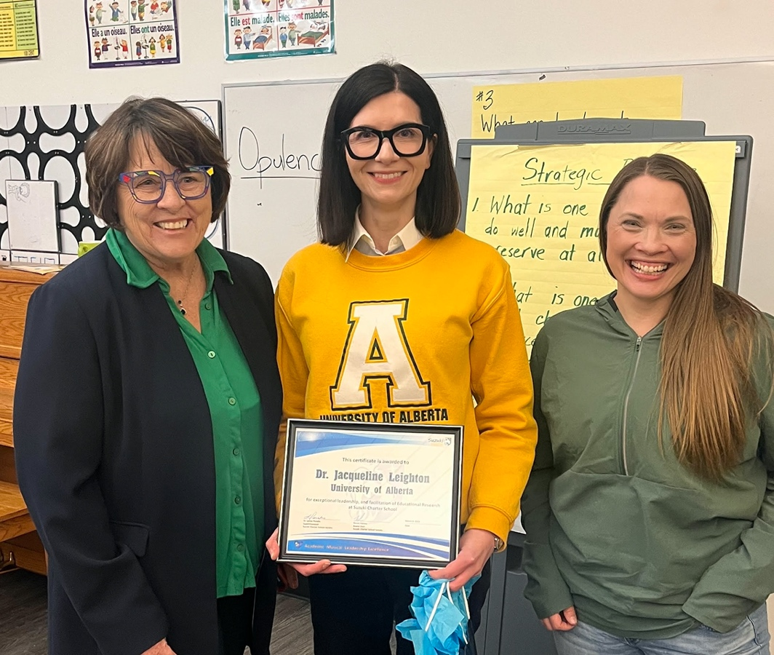

Identifying Formative Instructional and Assessment Strategies for Academic and Personal Excellence: Application of the LEAFF Model in K-6
Social Services and Humanities Research Project of Canada

Lead Researcher: Dr. Jackie Leighton, PhD, University of Alberta

SYNOPSIS OF RESEARCH PROJECT IN SIMPLE TERMSDr. J. Leighton, Lead Researcher and Dr. Lynne Paradis, Supt. of Suzuki Charter Public School
1. What was the original intent or motivation for the research?
The original motivation was to measure (a) the strength of trusting relationships between students and teachers, (b) students' motivation for learning and receipt of feedback, and (c) the application of a learning intervention to enhance students' understanding of teacher-feedback.
2. What were outcomes of the research?
There were a number of papers and conference presentations based on the research conducted at Suzuki. Please see attached.
3. How could the research potentially be applied at Suzuki Charter School?

The research can be applied by incorporating some of your findings into teacher instruction: (a) asking for more feedback from students about how they view instruction and teacher-based feedback, (b) providing less ambiguous and more concrete feedback, (c) incorporating more conversations with students about the process of making mistakes to lower anxiety about school performance.
4. Is there a potential message to the broader educational community on the outcomes of the research?

Yes, many of the results suggest that a human-rights approach to education might be considered by schools. One of the findings from the research is that students might benefit from having a greater 'voice' in the process of their education. For example, having more formalized conversations with children about school, tests, and feedback from teachers.
5. Are there suggestions to improve the research partnership and support provided by the school the research community?
From the perspective of the lead researcher: Rirst, having a researcher in residence would be helpful so that research is seen as something that is ongoing. Second, trusting the instruments of the research with fewer changes can help the quality of the results. Third, providing researchers with greater access to implementing research with the school and its students.
From the perspective of the Suzuki School Superintendent: Improvements in charter school research could be significantly improved with a modest commitment of funds from Alberta Education to support the research initiatives. Second, the outcomes of the research need to be shared with Alberta education communities in a systematic manner and the Ministry of Education could be very helpful in communicating this information to other school divisions for possible benefit to students across the province. Quality research is occurring and many principles and strategies to support active research in schools is also occurring. There are powerful messages to be shared with others but a system to do so will require Ministry support.

RESEARCH PROJECT – DIVING DEEPER INTO DETAILS
Suzuki Charter School and the LEAFF (Learning Errors and Formative Feedback) Model: Summary of SSHRC Research
Lead Researcher: Dr. Jackie Leighton, PhD, University of Alberta

AN OVERVIEW BY DR. JACKIE LEIGHTON

Human beings have the capacity to learn and live meaningfully when their social and emotional needs are met. Social needs include feeling connected and understood by other human beings. Emotional needs include feeling safe and in control. The rational, cognitive human brain evolved after the basic socio-emotional brain. Social and emotional needs prevail and must be met in childhood to support learning goals. Research indicates that approximately 60% of Albertans (and this is reflected in larger populations as well) will experience some form of serious childhood adversity with the potential to derail health and learning. The challenge for educators is of standing behind the curve instead of being in front of it; waiting for a child’s socio-emotional compass to go off-kilter before helping and intervening. Educators must be supported in finding ways to detect and prevent the off-balancing of social-emotional compasses. The research literature shows that many educational testing companies are seizing on the need for socio-emotional support and marketing diagnostic assessments and interventions for children and adolescents presenting behavioural problems. However, most of these commercial tools have not been developed on a solid research base but they fill a need. The objective of our SSHRC-funded research is to develop simple to use, evidence-based socio-emotional tools – curriculum materials, stories, assessments – that will complement and guide teacher-intuitions to help meet the socio-emotional needs of children in their math and science achievement. However, the vision for the project is larger - to develop a suite of engaging, simple and accessible, evidence-based tools to inform and guide parents and teachers in their pursuit of creating nurturing learning environments for children and adolescents. These preventive, research-based and tested tools could be promoted to parents, teachers, and schools in support of children and adolescents’ health and development as life-long learner. This research project spanned five years and was supported by a national SHRRC grant.
Many educational experts agree that there are a variety of excellent instructional and assessment tools (e.g., differentiated instruction, formative assessments). However, without clearly understanding the reasons why instructional and assessment tools work well with some learners and not others, it is difficult to (a) develop systematic evidence-based practices and (b) share these practices confidently with other educators and learners.
A major criticism of some forms of public spending on educational tools is that they are well intentioned but are subject to fads and may focus on short-term goals. Some of these fads may be ambiguous for teachers to implement and not work for many learners. Ceci, Papierno, and Mueller-Johnson (2002) describe the “twisted relationship” between school spending, meaningful learner access and academic outputs.
Suzuki Charter School (SCS) consistently demonstrates superior academic results. Often superior academic results are attributed to high levels of family education and income (SES). However, we have evidence to indicate this is not the main reason students at Suzuki perform so well. The SES profile of SCS is similar to many other schools in Edmonton. In 2012 and 2013, I collaborated with administrators, teachers and students at SCS to measure variables that we considered to be instrumental in reflecting the “Suzuki Approach” – an approach designed to nurture student engagement, motivation and strong learning. We found some very positive and interesting results using techniques that allow us to track data over time – for example, we found student trust in teachers predicted their empathy towards peers, their school engagement and not surprisingly their achievement and wellbeing. It makes intuitive sense that variables such as trust, empathy, engagement and wellbeing would enhance student learning but the question is how? What is it that teachers and students do in the classroom that builds this connection? Sharing this knowledge would be important for helping other educators and students, especially students at-risk for leaving school.
For the past decade, and prior to our work with SCS, we have been working on a learning and assessment framework (the Learning Errors and Formative Feedback [LEAFF] model) that focuses on how learning “climates” or environments influence students’ emotionally and socially for meaningful and long-lasting achievement. The LEAFF model was developed based on decades of conceptual and practical evidence on learning and performance, and it has been used to guide a series of large- and small-scale studies for understanding the conditions for meaningful learning. Recently, I was awarded a grant from the Social Sciences and Humanities Research Council of Canada (SSHRC) to investigate whether the LEAFF model can help us identify, understand and construct simple socio-emotional learning and assessment strategies to help learners achieve. SCS is an ideal partner school for this collaboration given its focus on personal and academic excellence.
The objectives of this collaborative research are to: (1) use the LEAFF model to guide the identification of key places in the math and science program of studies where simple but specific socio-emotional instructional and assessment strategies can be outlined (or constructed) to further promote student learning and wellbeing; (2) investigate specifically how these instructional and assessment strategies impact student wellbeing and learning, especially their comfort with feedback in subject areas where they wish to better perform and excel, relative to a control or comparison school; and (3) modify the learning and assessment strategies based on the “pilot” to see how these can be enhanced to support teachers and learners.

DIMENSIONS OF THE RESEARCH PROJECT

- MEET THE RESEARCHER
Dr. Jackie Leighton was the lead researcher for this project and worked collaboratively with the educational leaders at both Suzuki Public Charter School and Calgary Arts Academy Charter school as participants in the research project. Dr. Leighton has been on faculty at U of A for over 15 years, was Chair of the Department of Education Psychology for five years and has a respected list of international educational research publications. She is a strong advocate for Charter schools and the value that supporting educational research has on Alberta schools and the discipline of education in general.
- SUZUKI CHARTER SCHOOL PARTICIPATION
Suzuki Charter School was attracted to the suggestions to participate in this research. The school places a high priority on the establishment and maintaining of a safe and caring learning environment for children and faculty. The school staff had very positive experiences doing research with Dr. Leighton prior to this research study and was very interested in continuing work with Dr. Leighton. The Superintendent and school administration discussed time and resources needed to support the project and identified key contacts to be involved in a steering committee. As the project moved forward the possibility of adding a second school was discussed and soon Calgary Arts Academy Charter School joined as a partner. The research project was included in annual education plans for five years and each year adjustments were made to best support the research initiative.
- SHARING THE RESEARCH
Various approaches were utilized to share the research story with various stakeholders:
RESEARCH ASSISTANT - A research assistant, Vicky Qualie as assigned to the project and provided support in a variety of ways including data collection, in service for teachers, development of materials and tracking the progress of the project.
CONNECT newsletter – The research assistant provided teachers, admin and board members with a monthly newsletter that was produced with updates on the project. This update was stored on a research website managed by the lead researcher.
MONTHLY REPORTS TO STAFF AND SCHOOL BOARDS – The newsletter was shared with participating educators and any questions generated by discussions that emerged from sharing these reports was followed up on with the lead researcher.
ALBERTA RESEARCH NETWORK – Presentations, a poster disply and a panel discussion were included in two different annual Alberta Research Network conferences where key information about the research was shared with educators from across Alberta.
THE ASSOCIATION OF ALBERTA PUBLIC CHARTER SCHOOLS – The research story was part of the program for the bi-annual Charter School Conference attended by hundreds of Charter school teachers and administrators.
ANNUAL EDUCATION RESULTS REPORTS – Research highlights and progress were included in the educational plans and annual reports. This information was also shared with Alberta Education as part of annual deb-briefing meetings with Field Services Directors.
- IMPLICATIONS OF THE RESEARCH
To education improvement:
Many of the results suggest that a human-rights approach to education might be considered by schools. One of the findings from the research is that students might benefit from having a greater 'voice' in the process of their education. For example, having more formalized conversations with children about school, tests, and feedback from teachers.

To Suzuki Public Charter School
The research can be applied by incorporating some of your findings into teacher instruction: (a) asking for more feedback from students about how they view instruction and teacher-based feedback, (b) providing less ambiguous and more concrete feedback, (c) incorporating more conversations with students about the process of making mistakes to lower anxiety about school performance.

- INITIATION AND PREPARATION OF RESEARCH STUDY
The steering committee met and reviewed previous challenges in previous research initiatives that the schools and university had experienced. A decision was made to develop a partnership agreement that clearly outlined the roles and responsibilities of the participants. This document was helpful in keeping the research moving forward and reminding participants of their commitment to the project. It is included in the Appendix.
A celebration event was scheduled to initiative the beginning of the project to staff and the board. This involved welcoming the lead researcher and research assistant(s) as honorary members of the Suzuki school committee and was intended to draw intention to the purpose of the research study and the responsibility of all staff to support the initiative. It also served to provide visiting researchers with information about the school, the staff and the routines to feel welcome in the facility.
- TESTIMONIALS FROM THE TEACHER PARTICIPANTS
‘I learned a lot about what a research study involves.”
‘I have a better understanding of how complex quality educational research is and that the process is longer than I imagined.’
‘I have an appreciation for how much work is involved in carrying out educational research.’
‘I have changed some of my teaching approaches as an outcome of my involvement in this research study.’
‘My teaching staff have learned that research is an important dimension of professional personal learning.’

- SUPPORTING DOCUMENTS
Refer to the Appendix for the following:
A. Partnership Agreement – This document was key in keeping the research initiative moving forward.
B. Research and Publications

SUPPORTING DOCUMENT/REFERENCES

University of Alberta,
Department of Educational Psychology

Research-Practice Partnership
  - 27th September 2018

OVERVIEW
Dr. Jacqueline Leighton was awarded funding from the Social Sciences and Humanities Research Council (SSHRC) for the following project:
Identifying Formative Instructional and Assessment Strategies for Academic and Personal Excellence: Application of the LEAFF Model in K-6
This is a five-year project that explores the relationships between teachers and students within the context of teacher feedback. The Learning Errors and Formative Assessment (LEAFF) model is a learning and assessment model that provides simple and inclusive teaching practices to improve student-teacher engagement.
The purpose of this document is to invite partnering schools to participate in the research project via a research-practice partnership (RPP). The purpose of an RPP is to establish a formal collaboration between universities and schools to engage in mutually beneficial research.

GOALS OF THE RPP
- Formalize partnerships with schools with clearly defined goals, expectations, roles, communication strategies, and guiding principles.
- Assess each partner’s needs to ensure the project is valuable to all parties.

KEY STAKEHOLDERS (Direct for SSHRC Research)
Principal Investigator, Dr. Jacqueline Leighton: Professor at the University of Alberta. Oversees the deployment of grant funds in supporting the execution of the research study as outlined in the SSHRC Insight grant application. Primary contacts include superintendents and school principals.
Superintendent (District A), Dr. Lynne Paradis: Please describe role.
Superintendent (District B, To be Determined: Copy above role.
Principal (District A), Karen Spencer: Please describe role.
Principal (District B), To be Determined: Copy above role.
School Board (Districts A & B): Receives updates from superintendent to stay apprised of current research activities and status of the RPP.
Research Assistant, Vicky Qualie: Liaises with schools to schedule and deliver surveys to research participants, and works with Dr. Leighton to analyze the data and write the report.
Teachers (Districts A & B): Receive information about the project from school administrators and research staff as required. Teachers can decide to participate in surveys that inform the inquiry.
Parents (Districts A & B): Receive information about the project from school administrators and research staff as required. Parents can decide to allow their child to participate in surveys that inform the inquiry.
Students (Districts A & B): Receive information about the project from school administrators and research staff as required. With permission from their parents and an understanding of their role in the research, children can decide to participate in surveys that inform the inquiry.

ADVISORY BOARD COMPOSITION

Principal Investigator | Superintendents | Teacher Representatives
Research Assistant to take meeting notes.

GOVERNANCE
The basis of this RPP is a shared collaboration of the research project for a long-term, mutually beneficial relationship. In order to encourage significant collaboration, all key stakeholders are encouraged and invited to learn about the design and interpretation of the study. The research project should add value to the district and to the larger learning community, as well as meet the objectives of a nationally- and publicly-funded research project with specific scientific aims.

OPERATING PRINCIPLES

Trust | A trusting relationship among all key stakeholders leads to productive research that benefits everyone. Trust is developed over time through continuous opportunities to interact and share values.
Open Communication | All key stakeholders commit to sharing their feedback, including concerns, in a timely manner. All key stakeholders, in turn, commit to hearing this information with an open mind.
Scientific Integrity | The Social Sciences and Humanities Research Council of Canada (SSHRC) is a federal agency that supports research with scientific rigor that can be used to inform and address issues nationally and internationally. Grants are awarded via a competitive basis and are contingent on scientific merit. As such, the principal investigator assumes responsibility for the rigor and validity of the research, conclusion and scientific dissemination of the results. The principal investigator enters into a contract that funds will be spent according to the scientific aims of the study and if this is not possible that the investigator will make changes to the execution so that the original aims of the study can be met.
Ethical Standards | Researchers are bound by ethics to protect participants from harm, protect their confidentiality, and must be aligned not only with University of Alberta Ethics but also Tri-Council Ethical guidelines.
Flexibility | Schedules and circumstances can change. All partners commit to open communication that allows us to respond to unexpected changes with a flexible mindset. In case of unforeseen challenges, the investigator, research staff, superintendents, and school principals share a commitment to try and resolve the challenge with the aim of continuing the project forward.

COMMITMENT
It is important that all stakeholders understand the commitments required for this research project to be successful. The table below outlines the expectations of key stakeholders:

Stakeholder | Commits to:
Research Staff | - Clearly communicate the goals and objectives of the research project  - Clearly communicate consent parameters  - Develop research materials including qualitative surveys, quantitative data collection, and the intervention (e.g. storybook)  - Deliver surveys, collect data, and deploy the storybook  - Provide ongoing support to teachers as they interact with the storybook  - Receive feedback from research participants and consider any necessary changes to the delivery model or material content  - Analyze data and preparing report  - Share results with key stakeholders
Superintendents | - Review all project materials and grant permission to the researchers to conduct their research project  - Authorize school administrators to schedule the surveys and enable teachers to participate in meetings with research staff  - Inform Board Directors of the research project (e.g. goals, timelines, and commitments)  - Inform research staff of all potential risks to the project  - Inform Alberta Education of the project, with updates as we progress
Principals | - Inform teachers of the research project (with assistance from research staff, if explicitly requested)  - Provide a schedule to the research staff to deploy surveys and intervention tool  - Inform research staff of all potential risks to the project
Teachers | - Complete surveys  - Use intervention tools (e.g. storybook) and log experiences with intervention tools  - Participate in occasional focus groups  - Report concerns and questions to their principal or research staff (this line of communication needs to be explicitly articulated)
According to Ethical Guidelines, partner schools have the right to opt out of their commitment to the research project as their ongoing participation must always be voluntary. In the event that one partner school leaves the project, the principal investigator will reassess whether the project can continue at a single school or whether another partner school can be invited without disturbing the integrity of the research as per the investigator’s commitment to SSHRC. Likewise, the investigator can opt out of the partnership if the conditions for conducting the research fall short of the scientific integrity required of the research to meet its objectives and by SSHRC.

TIMELINES

Timeline | Tasks | Expectations
Phase 1  Fall 2018 | - Establish RPP | - All parties contribute to defining roles  - Reach an agreement on the governance and operating principles  - Formal commitment via signatures
Phase 1 - Fall 2018 | - Re-submit ethics application  - Meetings between research staff and school stakeholders  - Distribute and collect consent forms  - Refine intervention materials | - Researchers will obtain ethics approval from their Institutional Review Board  - Researchers are available to attend select meetings at the school (those deemed most crucial by school administrators)  - School administrators will communicate details of the project and distribute consent forms to the school community
Phase 2 - January to June, 2019 | - School visits to collect data  - School visits to launch intervention materials, focus groups with teachers (District A)  - School visits to monitor and assist with intervention materials (District A) | - Students are available to complete a 20 minute survey (Kindergarten to grade 2 via written surveys, grades 3-6 via electronic survey)  - Teachers are available to complete three electronic surveys for a total of approximately 90 minutes  - Teachers who are assigned the intervention tool (e.g. storybook) agree to the details of the intervention as will be determined in collaboration and note their experiences in the classroom  - School administrators provide student final grades to research staff
Phase 3 -  June to August, 2019 | - Data analysis  - Prepare written report, distribute for feedback and then release final version | - Researchers will conduct these tasks in a timely manner  - Advisory Board members are available to review the initial report
Phase 4 -  Fall 2019  *Winter 2020  *Fall 2022  *Winter  2023  *Not part of original partnership  discussions | - Refine intervention materials  - Prepare District B for intervention release, version 2  - Collect pre-intervention student and teacher surveys  - School visits to launch intervention materials (version 2), focus groups with teachers (District B)  - School visits to monitor and assist with intervention materials (District B)  Pandemic occurs and all on site research activities are halted.  Sharing of results with teachers and Suzuki Charter School Board.  Development of communications to share research story with other stakeholders (eg. Alberta Education, The Association of AB Public Charter Schools, Suzuki and Calgary Arts school communities). | - Teachers who are assigned the intervention tool agree to read it to their students and note their experiences in the classrooms  - Students are available to complete follow-up assessments (e.g., a 20-minute survey)  - Teachers are available to complete three electronic surveys for a total of 90 minutes  Research continues by lead researcher.  Results are compiled.  Follow up publications are completed.  Sharing of related publications with interested stakeholders.  Debriefing with school participants.  Follow up professional development  Discussions on strategies to make improvements to research processes between Charter schools and the University of Alberta.
PUBLICATIONS RELATED TO RESEARCH

- Leighton, J.P. (2023). Leveraging Socio-Emotional Assessment to Foster Children’s Human Rights. Part of the Student Assessment for Educators (Book Series Editor - J. McMillan). Oxfordshire, UK: Routledge (Taylor & Francis Group).
- Leighton, J.P. (2022). Not all that counts is safe for counting: Barriers to collecting learning data for assessment purposes. In R. Lissitz and H. Jiao (Eds.), Enhancing effective instruction and learning using assessment data (pp. 187-213). Information Age Publishing.
- Liu, Y. & Leighton, J.P. (2021). Parental self-efficacy in helping children succeed in school favors math achievement. Frontiers in Education (Educational Psychology). doi: 10.3389/feduc.2021.657722
- Leighton, J.P. (2020). On barriers to accessing children’s voices in school-based research. Canadian Journal of Children’s Rights, 7(1), 164-193.
- Leighton, J.P. (2019). Cognitive diagnosis is not enough: The challenge of measuring learning with classroom assessments. In S.M. Brookhart & J.H. McMillan (Eds.), Classroom assessment and educational measurement (pp. 27-45). NCME Book Series. Routledge.
- Leighton, J.P. (2019). Students’ interpretation of formative feedback: Three claims for why we know so little about something so important. Journal of Educational Measurement (Special Issue on Classroom Assessment), 56, 793-814.DOI: 10.1111
- Leighton, J.P. (2019, November 7-8). Not all that counts is safe for counting: Empirical barriers to collecting learning data for assessment purposes. Presentation delivered at the 19th Annual Maryland Assessment Research Centre (MARC) Conference (Enhancing Effective Instruction and Learning Using Assessment Data). Maryland, USA.
- Leighton, J.P., & Qualie, V. (2019, June). Teachers’ perspectives on learning assessment errors and feedback. Paper presented at the annual meeting of Canadian Society for the Study of Education, Vancouver, BC, CANADA.
- Qualie, V., Leighton, J.P., Liu, Y., & Orr, A. (2019, June). Children's perceptions of trust, mistakes and feedback help predict academic achievement across domains. Poster presented at the annual meeting of the Canadian Psychological Association. Halifax, NS, CANADA.
- Liu, Y., & Leighton, J.P. (2019, April). Parental involvement in children’s math achievement. Poster to be presented at the annual meeting of the American Educational Research Association (AERA). Toronto, ON, CANADA.
- Leighton, J.P., Guo, Q., Chu, M-W., & Tang, W. (2018). A Pedagogical Alliance for Academic Achievement: Socio-Emotional Effects on Assessment Outcomes. Educational Assessment, 23(1), 1-23.
- Leighton, J.P., (2018, April). Students’ Affective Reactions and Cognitive Understanding of Classroom Mistakes and Related Feedback. Paper presented at the session on Being Wrong (Sometimes): How Students’ Classroom Assessment Mistakes and Learning Errors Enhance Learning and Motivation (Chair: James McMillan) at the annual meeting of American Educational Research Association (AERA) SIG Classroom Assessment, New York City, USA.
- Leighton, J.P., Seitz, P., Chu, M-W., & Gomez Bustos, M.C. (2016). Operationalizing the role of trust for student wellbeing, learning and achievement. International Journal of Wellbeing, 6(2), 57-79.
- Leighton, J.P., Guo, Q., Chu, M-W., & Tang, W. (2016, April). A panel structural equation model of the effects of trust and sympathy on learner outcomes. Poster presented the annual meeting of the American Educational Research Association (AERA), Washington, DC, USA.

